Hi everyone,
Hope you are all doing good & tried your best on your work from last week. Well done on the work you completed! Below you will find your assigned work for this week. We hope you are all enjoying building your castles. We are really looking forward to seeing pictures of them. Please continue with this art project this week.
We hope you are still getting up early, having a good healthy breakfast and doing some exercise each morning, as well as getting some fresh air every day.
If work becomes too difficult, take a break. Choose an activity that you enjoy such as reading, listening to music or doing some meditation. Remember all we want you to do is try your best. Have a lovely week.
This week we have included an interesting ‘Explorer’s Pack’ from EPIC museum. This pack will cover all SESE topics so take your time going through it all. Your parents will find it at a separate link on the school website below this.
All the best,
Ms. Gibson, Ms. Kearney, Mr. Gleeson & Ms. Mitchell
Timetable for the Week
Monday
Maths: Mental Maths: Week 32 pg. 95
Busy at Maths: Watch this video https://youtu.be/S7TJHHclzFg and complete page 96.
English: Read ‘Fooled by Words’ and answer part A.
At least 15 minutes reading a book of your choice and write the summary sentences in copy.
Gaeilge: Complete Measunú on “Sa Bhaile” into your copy.Spend 15 minutes on Bua na Cainte activties.
SPHE: 5 minutes meditation
SESE: Explorer’s Pack pages 1 – 4.
Music:

Tuesday
PE: The Body Coach will be doing a live workout each day at 9.00 a.m.
Maths: Mental Maths: Tuesday Page 95
Busy at Maths: Rewatch the video if you think it will help and complete page 97.
English: Reading Zone part B.
At least 15 minutes reading a book of your choice and write the summary sentences in copy.
Gaeilge: Complete page by working with a partner. Write your responses in your copy first.
Spend 15 minutes on Bua na Cainte activities.
SPHE: 5 minutes meditation
SESE: Explorer’s Pack pages 5 – 8.
Music:

Wednesday
PE: The Body Coach will be doing a live workout each day at 9.00 a.m.
Maths: Mental Maths Wednesday Page 96
Busy at Maths: Complete p. 98
English: Reading Zone part C.
At least 15 minutes reading a book of your choice and write the summary sentences in copy.
Complete 4 lines of handwriting.
Gaeilge: Spend 15 minutes on Bua na Ciante activities. Rewrite the vocabulary in your copy & try to remember their meanings.
SESE: Explorer’s Pack page 9.
Music:
SPHE: 5 minutes meditation

Thursday
PE: The Body Coach will be doing a live workout each day at 9.00 a.m.
Maths: Mental Maths: Thursday Page 96
Problem of the Week. It should be a fun one.
English: Reading Zone part D.
At least 15 minutes reading a book of your choice and write the summary sentences in copy.
Complete 4 lines of handwriting.
Gaeilge: Read & listen to the poem. Read it out loud & record yourself reading it. Aim to improve your pronunciation after first go.
SESE: Explorer’s Pack page 10.
S.P.H.E.: 5 minutes meditation
Music:

Friday
PE: The Body Coach will be doing a live workout each day at 9.00 a.m.
Maths: Mental Maths: Friday page 97
B. A. M : Watch this new video https://youtu.be/M3x8bXIPryY and complete page 99.
English: Reading Zone part E
At least 15 minutes reading a book of your choice and write the summary sentences in copy.
Finish handwriting page.
Gaeilge: www.cula4.com Watch a programme on the player or play a game for 15 minutes.
Art: Continue on with your castle, using cardboard or any recycled materials you have at home.
Music:
SPHE: 5 minutes meditation

Maths:
Busy at Maths: This week we are doing 3D Shapes.
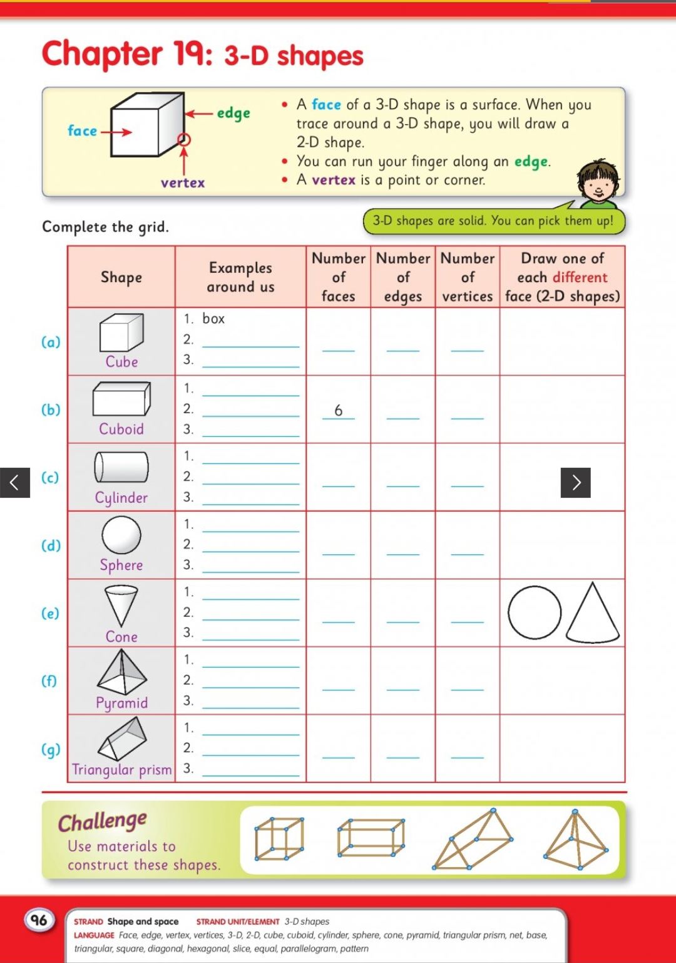

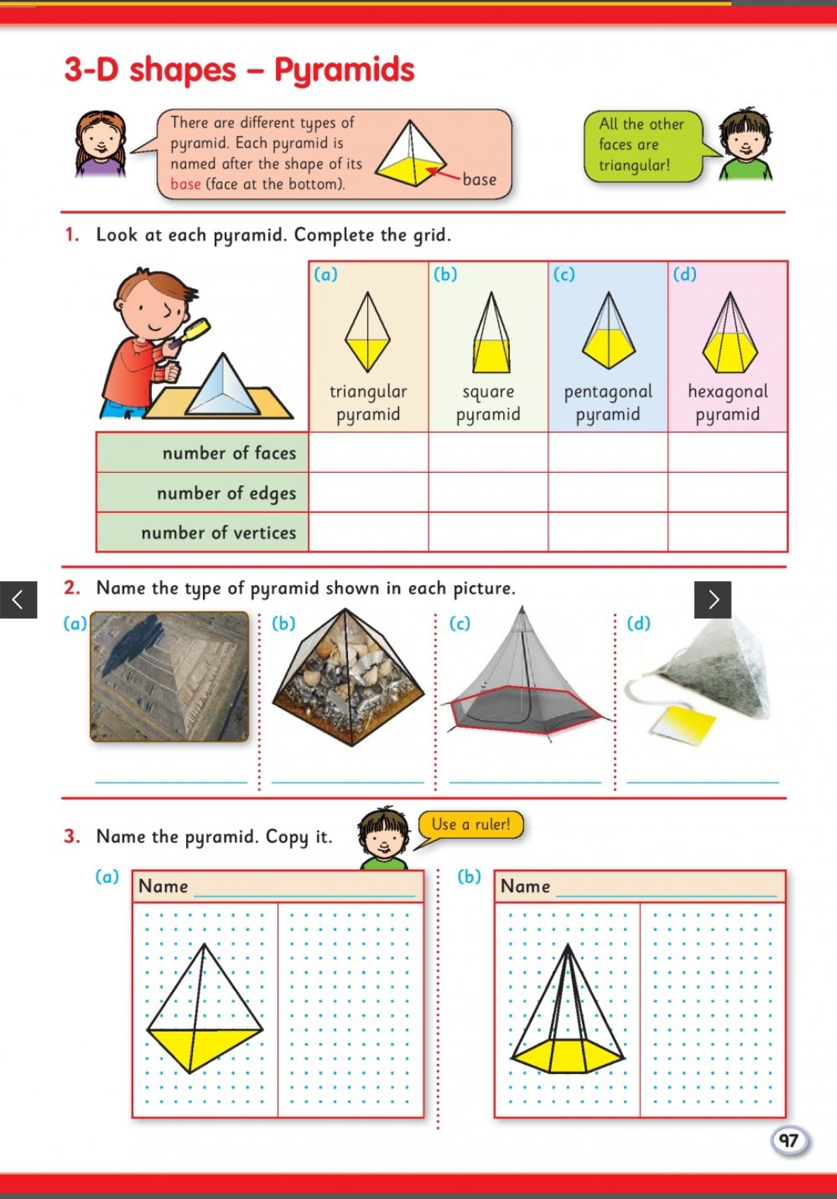

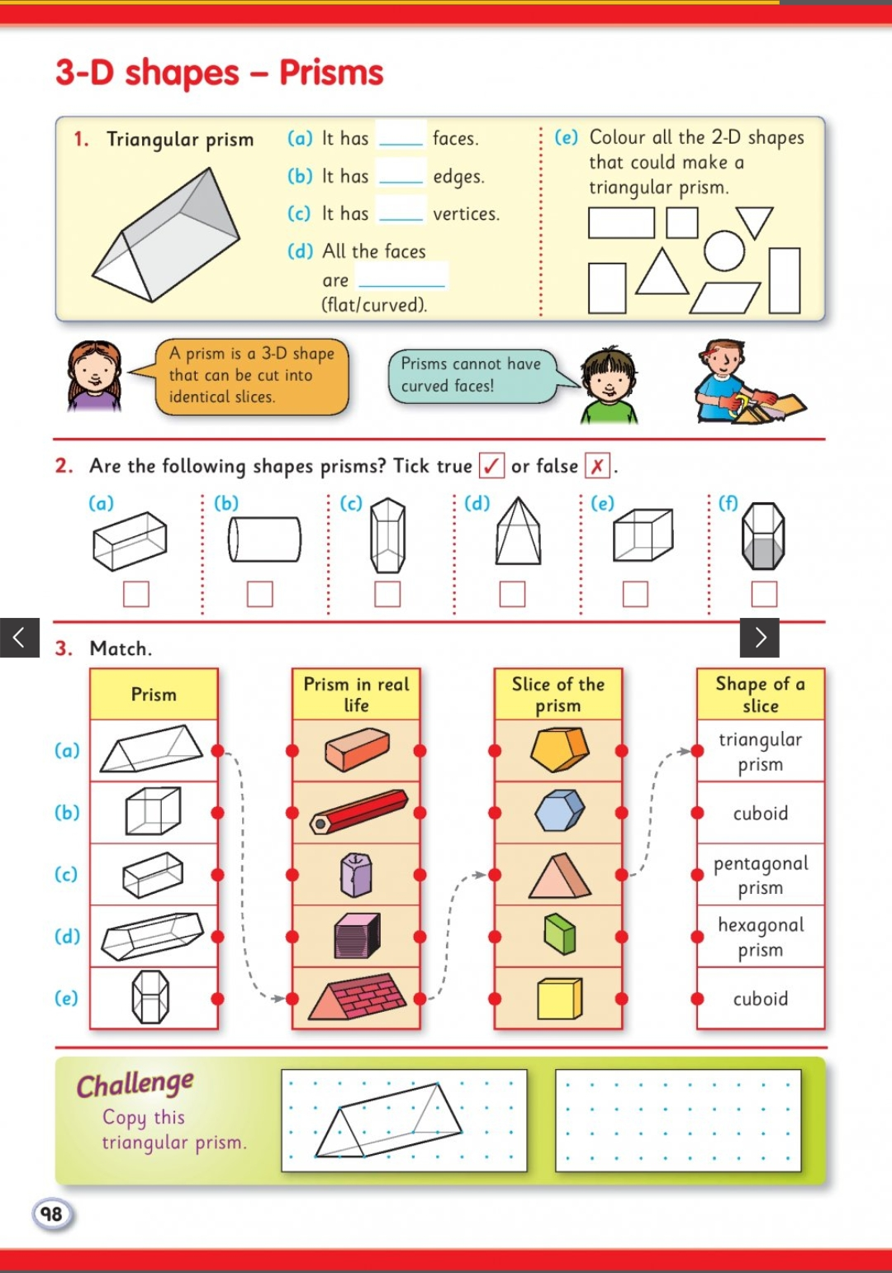

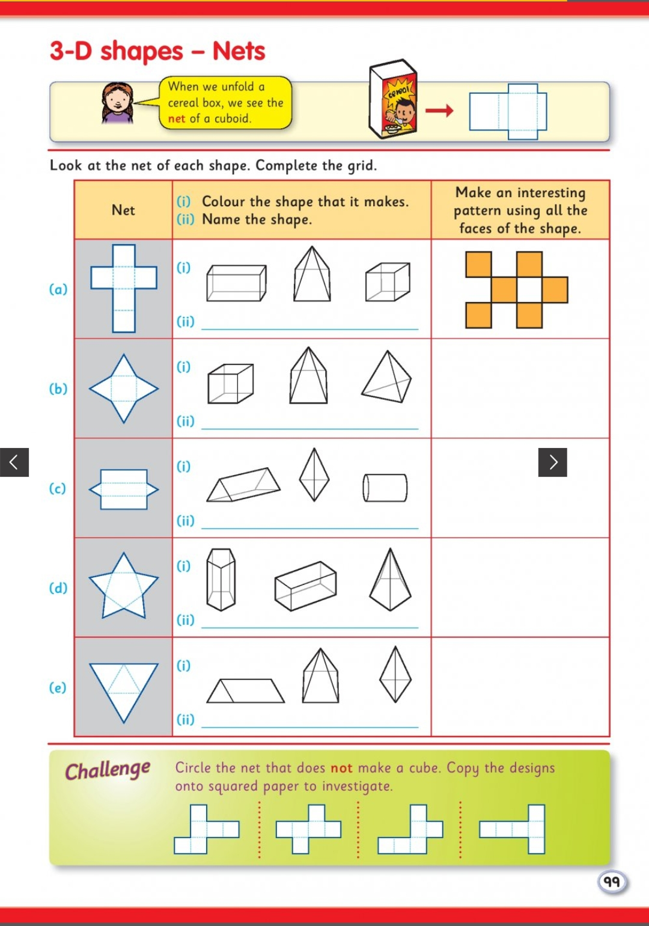

Problem of the Week:

One Big Triangle
Here are nine triangles. Each one has three numbers on it.
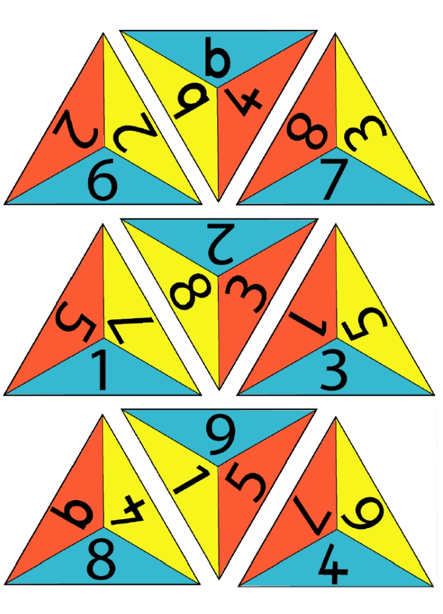Your challenge is to arrange these triangles to make one big triangle, so the numbers that touch add up to 10. (Be careful with the 6 and 9’s, I was getting them mixed up and couldn’t get it to work)

You can print out the triangles from the picture above, or from this page https://nrich.maths.org/content/01/04/letme1/One%20big%20triange.pdf ,or you could draw them out.

English:
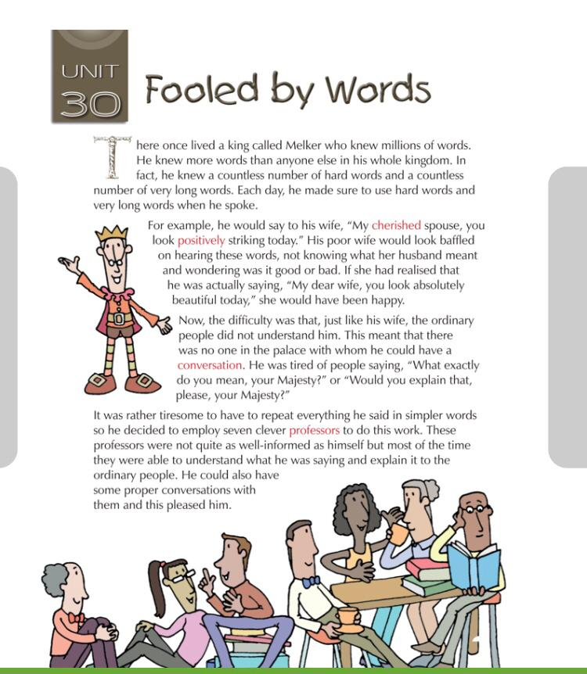
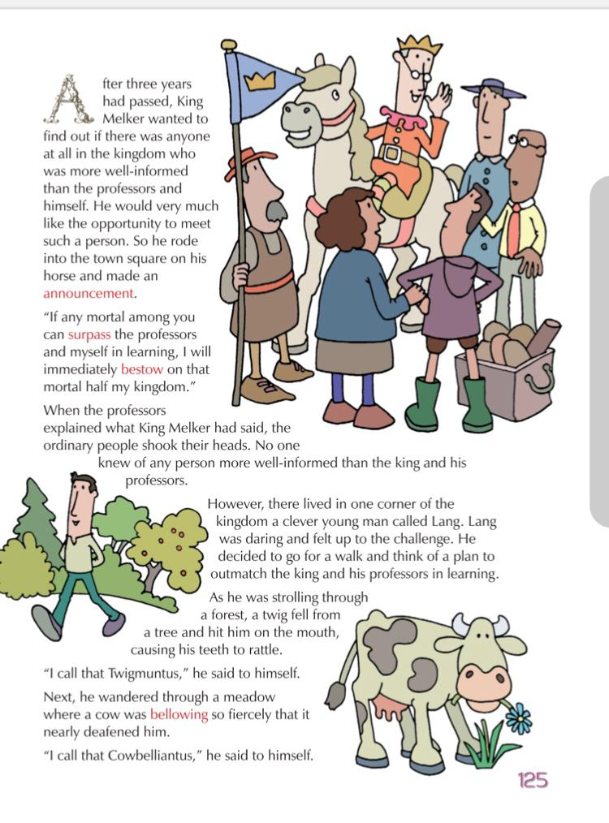
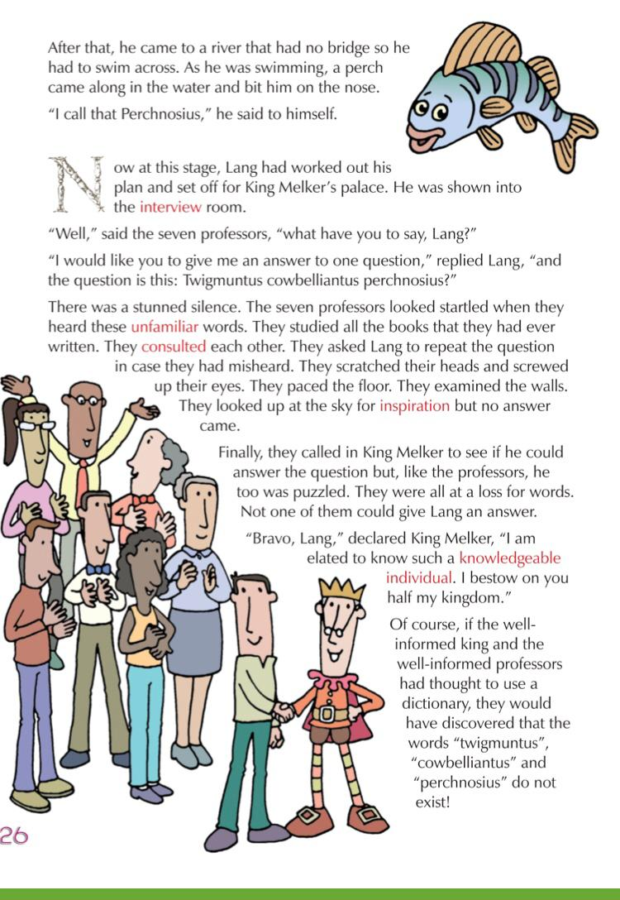
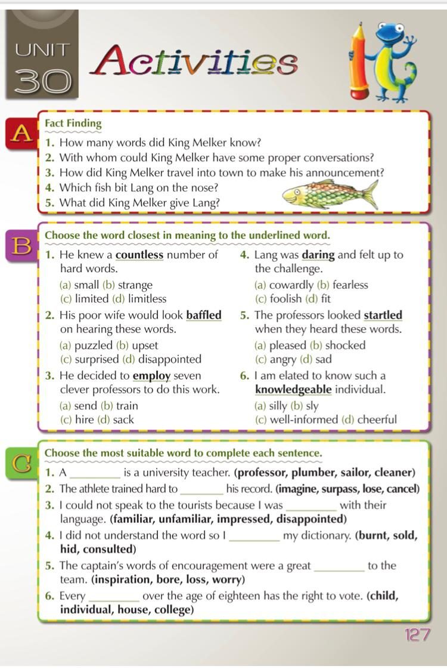
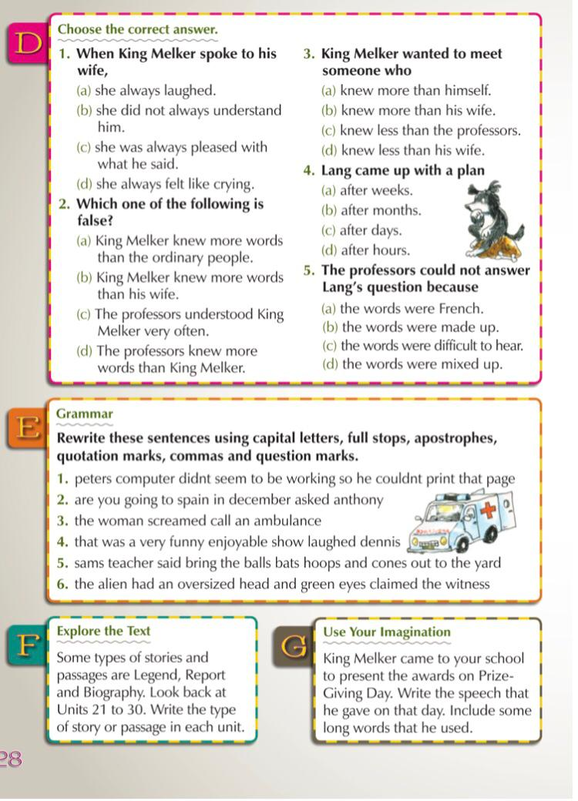

Gaeilge:
Bua na Cainte is the interactive program we have been using to teach Irish. The children have been using this over the last number of years so they should be confident in navigating through the activities.
Please follow the steps below to gain access to this resource (It is a large file but it’ll remain on your computer for your child to use once its downloaded): 1. Go to http://www.edco.ie/bua
2. Click on the folder that matches the device you are installing it onto – mac or laptop
3. Choose the class group your child is in and click on the setup icon to install it onto your device.
4. Once it is installed, you can open up the program and enter the login details.
5. Password: trial
Username: trial
Your child will be aware of the themes we have covered since September so please allow them to go back over these activities to revise the work they have covered. There is also matching activities to the theme we are currently covering – Sa Bhaile/ Teilifís.
Foclóir Nua
Lampa = lamp  Grianghraf – photo  Táibléad - tablet  Cianrialtán - remote control  Cnámh - bone  Teasáire - heater  Faoin - under  (g)cúisín - cushion  Cúirtíní - curtains  Dallóg - blind | Bláthchuach - flower vase  In aice leis - beside  an mbord – the table  Taobh thiar den - behind  tolg – couch/sofa  Ag imirt cluiche – playing games  Os cionn - over  na tine – the fire  Ar an – on  Matal - mantlepiece
Revise the words from the previous work you have completed and answer the questions into your copy.
e.g. Cád atá faoin bhfuinneog? Tá an teasáire faoin bhfuinneog.
Ring a friend or work with someone at home and ask them the questions on page 160.
Read & listen to the poem on page 166.

